Two-Dimensional Arrays

A two-dimensional array is a collection of data of the same type that is structured in two dimensions. Individual variables are accessed by their position within each dimension. You can think of a 2-D array as a table of a particular data type. The following example creates a 2-D array of type string:

string[,] twoDimAry = new string[4,3];

twoDimAry is an array variable that has 4 rows and 3 columns. Each row and column entry is of type string. The following code fragment generates a 4x3 multiplication table:

int[,] multTable = new int[4, 3];

// Create multiplication table
int x, y;
for (x = 0; x < 4; x++)
for (y = 0; y < 3; y++)
{
multTable[x, y] = x * y;
}

// Output multiplication table
// Iterate through y first to output each x value on one line
for (y = 0; y < 3; y++)
{
for (x = 0; x < 4; x++)
{
Console.Write(y + " * " + x + " = " + multTable[x, y] + " ");
}
Console.WriteLine();
}

This program outputs the following table of data:

0 * 0 = 0 0 * 1 = 0 0 * 2 = 0 0 * 3 = 0
1 * 0 = 0 1 * 1 = 1 1 * 2 = 2 1 * 3 = 3
2 * 0 = 0 2 * 1 = 2 2 * 2 = 4 2 * 3 = 6

Processing a two-dimensional array variable requires two loops: one for the rows and one for the columns. If the outer loop is the index for the column, the array is processed by column. If the outer loop is the index for the row, the array is processed by row.

Multidimensional Arrays

You have seen one-dimensional and two-dimensional arrays. In C#, arrays may have any number of dimensions. To process every item in a one-dimensional array, you need one loop. To process every item in a two-dimensional array, you need two loops. The pattern continues to any number of dimensions. To process every item in an n-dimensional array, you need n loops.

For example, if we wanted to declare an array of 3 dimensions, each with 10 elements, we could do so via;

int[,,] threeD = new int[10,10,10];

Drawing Shapes and Rectangles

As an example of 2D arrays we’re write a fire simulator. This is a somewhat longer example than what we’ve done so far. First we need a way to visualize the 2D array. To do that we will draw a representation of the array in a picturebox using rectangles.

To experiment with drawing graphics within a picturebox, add a PictureBox control to the form. In the Properties window for the Picturebox, select events (the lightning bolt) and the Paint event:

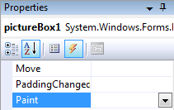

The Paint event is automatically invoked whenever the PictureBox needs to be redrawn. For example, if the form is minimized, dragged, or occluded, then when the form is activated the Paint event will be invoked. By placing the drawing code in the Paint event it will always be updated correctly. If we placed the code somewhere else and the window was obscured, it may not be redrawn correctly when the obscuring item is moved out of the way.

We can now put code in the Paint event that will draw whatever we like on top of the PictureBox.

Here is some sample code we can add to the Paint event to draw various shapes on the screen:

private void pictureBox1_Paint(object sender, PaintEventArgs e)
{
// Get the graphics object for the event (i.e. the PictureBox)
Graphics g = e.Graphics;

// Draw a red rect with Width=50, Height=80 at coord 10,20
g.DrawRectangle(Pens.Red, 10, 20, 50, 80);

// Make a new pen of width 4
Pen thickPurplePen = new Pen(Color.Purple, 4);
// Ellipse in purple, width 4, within bounding rectangle at 50,10
g.DrawEllipse(thickPurplePen, 50, 10, 40, 30);

// Draw a line from 10,10 to 50,50 of width 1
g.DrawLine(Pens.MediumSeaGreen, 10, 10, 50, 50);

// To fill in a shape we must use a brush
SolidBrush bru = new SolidBrush(Color.GreenYellow);
// Fill in the rectangle
g.FillRectangle(Brushes.GreenYellow, 100, 100, 50, 20);

// Draw part of a pie
g.FillPie(Brushes.IndianRed, 130, 20, 100, 100, 30, 60);

// Draw the text "Abstract Art" in font Arial, size 12, in Indigo
g.DrawString("Abstract Art", new System.Drawing.Font("Arial", 12),
Brushes.Indigo, 50, 140);
}

First, we capture the Graphics object from the event arguments. The Graphics object is required to draw graphics on the screen. Remember that everything will be drawn relative to the upper-left corner of the PictureBox.

Next, we create a red pen and draw a rectangle using that pen. The rectangle takes the coordinates of the upper left corner then the width and height.

An ellipse is drawn in a similar fashion, by specifying the bounding rectangle that holds the ellipse. This time we create a new pen object. The new pen object can specify the width of the item to draw.

Next we draw a single line using the MediumSeaGreen pen.

Next we draw a solid rectangle using a Brush object. The Brush in this case is a solid color, but it is possible to create brushes that are hatched, texture, etc. Finally we draw part of a Pie slice using a red brush.

Finally we draw text toward the bottom of the screen using DrawString. You can pick whichever font you like that is on the system.

The picture created is shown below:
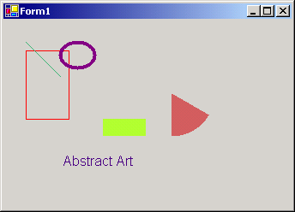

There are many other drawing tools available; see the book or online help for more details.

Note that we should always draw the items in the Paint event, or the items won’t be refreshed properly if the screen needs to be re-drawn. For example, if the above code was placed in a Button Click event, the items would be drawn when the button is clicked but not when the form needs to be refreshed.

We can tell the computer to refresh a picturebox with:

pictureBox.Invalidate();

Forest Fire Modeling
Adapted from http://ccl.northwestern.edu/netlogo/models/Fire

For our example let’s use a 2D array to make a simple forest fire model. We’ll use a 2D array of integers where the integer value represents either a tree (flammable) or a clearing (non-flammable). Let’s initially make this 150 cells wide by 150 cells tall. Here are some variables:

private const int WIDTH = 150;
private const int HEIGHT = 150;
private int[,] landscape = new int[WIDTH, HEIGHT];
private const int TREE = 1;
private const int CLEARING = 0;

For example if the array looks like this:

1 | 0 | 0 | 0
1 | 0 | 1 | 0
1 | 1 | 1 | 0
1 | 0 | 0 | 1

The upper left coordinate is (0,0) and x increases to the right and y increases down, just like the regular graphics coordinates. This means there are trees all the way down the left side (x = 0). In the top row there is a tree on the left and then clearing all the way to the right. We can use the constant TREE and CLEARING instead of 1 and 0 to make our program a bit more readable.

Let’s begin by randomly populating the array with trees. We can make a tree density textbox and a setup button:
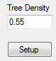

In the setup button click we set a cell to a TREE if a random number is less than the density entered in the textbox. Otherwise the cell becomes a clearing. Finally we will set all the trees on the left side of the array to be on fire.

private void btnSetup_Click(object sender, EventArgs e)
{
double probability = double.Parse(txtDensity.Text);

// 0,0 is the upper left corner
for (int x = 0; x < WIDTH; x++)
for (int y = 0; y < HEIGHT; y++)
{
if (rnd.NextDouble() < probability)
landscape[x, y] = TREE;
else
landscape[x, y] = CLEARING;
}
// Set all the trees on fire on the left side, where x = 0
for (int y = 0; y < HEIGHT; y++)
if (landscape[0,y] == TREE)
landscape[0, y] = FIRE;
}

This requires adding a class variable to generate random numbers and another constant to represent fire:

private Random rnd = new Random();
private const int FIRE = 2;

Now that we have filled in the array, the next thing we need to do is to view it somehow. We can do this by adding a PictureBox and using the FillRectangle method. Every cell in the array maps to a square in the picturebox. To make the cells visible we’ll make each entry map to a 4x4 pixel square, e.g.:

1 | 0 | 0 | 0
1 | 0 | 1 | 0
1 | 1 | 1 | 0
1 | 0 | 0 | 1

Is drawn as

Note that with a 4x4 pixel square we want cell (0,0) to be drawn with upper left corner at (0,0) with width 4 and height 4 (to coordinates 3,3). The cell at (1,0) should be drawn with its upper left corner at (4,0), the cell at (1,1) should be drawn with its upper left corner at (4,4), the cell at (1,2) should be drawn with its upper left corner at (4,8), etc.
The simple mapping becomes:

Cell (x,y) gets drawn at (x*4, y*4) with width 4, height 4

First we add a picturebox to the form, in this case I called it pboxForest and made it 600x600.
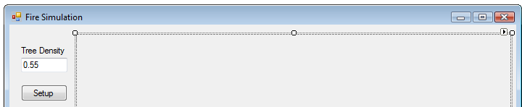

Next we add a Paint method and add this code to it:

private void pboxForest_Paint(object sender, PaintEventArgs e)
{
// Draw the array as an image
Graphics g = e.Graphics;
Brush b;

for (int x = 0; x < WIDTH; x++)
for (int y = 0; y < HEIGHT; y++)
{
if (landscape[x, y] == CLEARING)
b = Brushes.Black;
else if (landscape[x, y] == TREE)
b = Brushes.Green;
else
b = Brushes.Red; // Fire is the only thing left
g.FillRectangle(b, x*4, y*4, 4, 4);
}
}

To force the paint method to be called when the Setup button is clicked, add the following at the end of the btnSetup_Click method:

// Repaint the picturebox
pboxForest.Invalidate();

Clicking the Setup button should now change the picturebox:

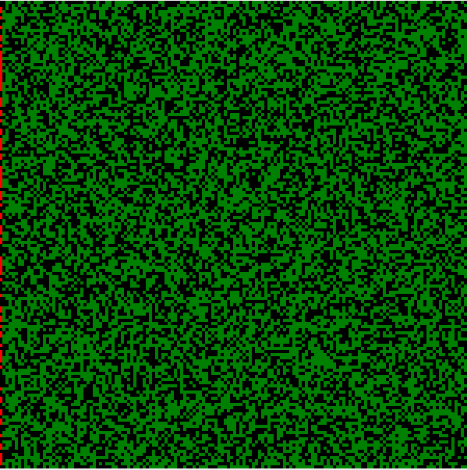

Now we’re ready to burn! Our simulation is very simple. It will run in discrete time steps. Every step we will loop through every cell in the forest. If a cell is on fire, then in the next time step any tree to the north, south, east, or west will also be set on fire. The cell on fire will burn out and become clearing in the next time step.

So for example, if the cells look like this:

Then the next time step looks like this:

To accomplish this task let’s add another state to the 2D array to represent a new fire:

private const int NEWFIRE = 3;

The reason to introduce this new constant is to distinguish between current fire (which goes out the next time step) and new fire (which remains lit the next time step). If we only had one type of fire then there is the possibility for confusion where we treat new fire like current fire (i.e. make it spread when it shouldn’t) or vice versa.

Here is code that simulates one step of burn:

private bool burnOneStep()
{
bool foundBurn = false;

for (int x = 0; x < WIDTH; x++)
for (int y = 0; y < HEIGHT; y++)
{
if (landscape[x, y] == FIRE)
{
foundBurn = true; // We found something burning

// Burn neighbors but don't go off the edges of the array
if (x > 0) // Check left
{
if (landscape[x - 1, y] == TREE)
landscape[x - 1, y] = NEWFIRE;
}
if (x < WIDTH - 1) // Check right
{
if (landscape[x + 1, y] == TREE)
landscape[x + 1, y] = NEWFIRE;
}
if (y > 0) // Check up
{
if (landscape[x, y - 1] == TREE)
landscape[x, y - 1] = NEWFIRE;
}
if (y < HEIGHT - 1) // Check down

{
if (landscape[x, y + 1] == TREE)
landscape[x, y + 1] = NEWFIRE;
}
}
}
if (foundBurn == false)
return false;

for (int x = 0; x < WIDTH; x++)
for (int y = 0; y < HEIGHT; y++)
{
if (landscape[x, y] == FIRE)
landscape[x, y] = CLEARING;
else if (landscape[x, y] == NEWFIRE)
landscape[x, y] = FIRE;
}
return true;
}

The foundBurn variable is used to determine if anything is left burning. If not, then false is returned. Otherwise true is returned if at least one tree is on fire.

The code works by looping through every cell. If one is on fire, then its neighbors get set to NEWFIRE if there is one that is a tree. Then all the FIRE cells become CLEARING and all the NEWFIRE cells get set to FIRE for the next time step.

We can add a Burn button and have it repeatedly call burnOneStep until it returns false:

private void btnBurn_Click(object sender, EventArgs e)
{
bool isBurning = true;
while (isBurning)
{
isBurning = burnOneStep();
}
pboxForest.Invalidate();
}

Clicking the button burns the forest but doesn’t animate the burn step by step. This is because the program uses up all the CPU time for calculating the burning and doesn’t update the picturebox which gets lower priority. One way to make the animation happen is to use a timer. Every certain number of milliseconds we can calculate the burning step. The picturebox is updated while waiting for the timer to go off again.

This technique requires adding a timer to the form. It will appear on the bottom. In this case I called it timerBurn:

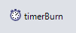

Under properties set the Interval to 20. This means the timer will go off every 20 milliseconds. To add code that is run when the timer goes off, double-click on the timer and a timer tick method is created.

private void timerBurn_Tick(object sender, EventArgs e)
{
bool isBurning = burnOneStep();
pboxForest.Invalidate();
if (isBurning == false)
timerBurn.Enabled = false;
}

This runs one burn step then invalidates the picturebox so it can be redrawn. After another timer interval has elapsed, the code is executed again.

To start the timer, enable it in the btnBurn_Click method:

private void btnBurn_Click(object sender, EventArgs e)
{
timerBurn.Enabled = true;
}

Clicking the burn button should give you an animated burn!

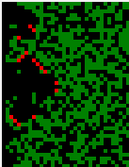

Everything we have covered up to now is available as a Visual Studio project under Exercise 17.

One parameter to play with is to change the density. You’ll notice a very small increase in density (up to 60%) almost always results in a massive swath being burned, while just a tiny decrease to 55% results in a relatively small burn area. It turns out that at 59% density the fire has a 50% chance of reaching the right side of the forest.

If the model is accurate (and it’s greatly simplified and missing many factors in a real fire) the implications are that thinning trees can have a great impact on preventing the spread of fire.

