Introduction to Debugging

If a program is not running the way you intend, then you will have to debug the program. Debugging is the process of finding and correcting the errors. There are two general ways to go about debugging:

- Add Console.WriteLine or MessageBox statements at strategic points in the program to display the values of selected variables or expressions until the error is detected.

- Use an integrated debugger the lets you pause, view, and alter variables while the program is running. Such a tool is called a debugger.

Debugging with WriteLines

Let’s first examine the WriteLine method. Although somewhat “primitive” it is useful since it works in virtually any programming environment. Consider the following program which converts a temperature from Fahrenheit to Celsius using the formula:

private void btnConvert_Click(object sender, EventArgs e)
{
int celsius;
int fahrenheit;
const int CONVERSIONFACTOR = 5 / 9;

fahrenheit = int.Parse(txtTempF.Text);
celsius = CONVERSIONFACTOR * (fahrenheit - 32);
MessageBox.Show("The temp in Celsius is " + celsius.ToString());
}

When run, it compiles and executes but gives incorrect outputs. For example, on an input of 100 F, we get 0 C, which is incorrect. What is wrong?

One technique is to add WriteLine statements to output intermediate values of interest:

private void btnConvert_Click(object sender, EventArgs e)
{
int celsius;
int fahrenheit;
const int CONVERSIONFACTOR = 5 / 9;

fahrenheit = int.Parse(txtTempF.Text);

Console.WriteLine("Fahrenheit = " + fahrenheit);
Console.WriteLine("Conversion = " + CONVERSIONFACTOR);

celsius = CONVERSIONFACTOR * (fahrenheit - 32);
MessageBox.Show("The temp in Celsius is " + celsius.ToString());
}

The program outputs to the console:

Fahrenheit = 100
Conversion = 0

The Conversion factor is obviously incorrect! This should give you enough information to see that the variable was defined incorrectly as an int and truncated to 0, since an integer cannot store the number 5 / 9 .

The first correction is to change this to a double. This requires also converting the resulting double to an int when we store into Celsius:

private void btnConvert_Click(object sender, EventArgs e)
{
int celsius;
int fahrenheit;
const double CONVERSIONFACTOR = 5 / 9;

fahrenheit = int.Parse(txtTempF.Text);

Console.WriteLine("Fahrenheit = " + fahrenheit);
Console.WriteLine("Conversion = " + CONVERSIONFACTOR);

celsius = (int) (CONVERSIONFACTOR * (fahrenheit - 32));
MessageBox.Show("The temp in Celsius is " + celsius.ToString());
}

If we run this new version we still get zero! That is because 5/9 is computed with integer division, giving us zero, and then the zero is converted to a double. The fixed version performs floating point division by making one of the operands a floating point number:
const double CONVERSIONFACTOR = 5.0/9;

Once the error is found and detected, then using the WriteLine method we would then remove or comment out the WriteLine statements that helped us track down the source of the error.

Using the Integrated Debugger

While the process described above works, it is somewhat tedious to all of the WriteLine statements and them remove them. A much nicer technique is to use the built-in debugger.

Visual Studio .NET programs run in one of three modes – design mode, run mode, or break mode. The current mode is displayed in parentheses in the Visual Studio title bar. Design mode is where you design the program. Run mode is when you run the program. Break mode is when you pause the program to debug it.

If we return to the original program with the bugs, one way to enter break mode is to add a breakpoint. A breakpoint stops execution at a particular line of code and enters Break mode. This is useful when you know that a particular routine is faulty and want to inspect the code more closely when execution reaches that point.

To set a breakpoint, click in the border to the left of the code. A red dot will appear. Click the same dot to turn the breakpoint off.

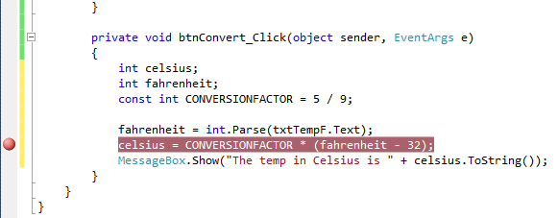

When we run the program and reach this code, the program automatically enters Break mode and stops. Execution stops before the line with the breakpoint is executed. The current line is indicated in yellow:

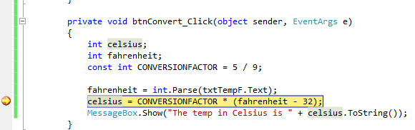

The first thing we can do is inspect the value of variables. One way to do this is to hover the mouse over the variable or constant, and a popup window will display its contents:

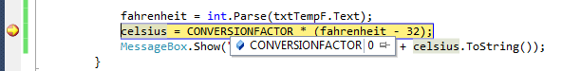

In this case, I have hovered over “ConversionFactor” and its value is displayed as 0. This by itself would give us enough information to debug the program. Note that we did not have to add any WriteLine statements!

We can also immediately see the contents of all the active variables by looking in the “Locals” window:

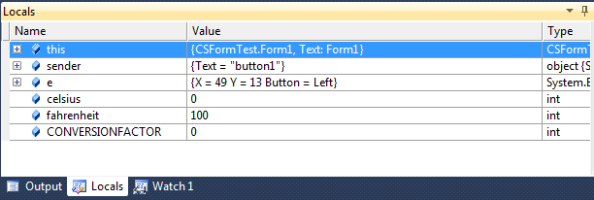

If a value is displayed in red this indicates that the variables has just been changed.

To illustrate this, we can now step through the program one line at a time using the buttons:

These buttons are used respectively to step into a method, step over a method, or step out of a method. We can use these buttons and view our variables change as we run the program. When we define our own methods this will make more sense, but for now the first two buttons do the same thing when we’re executing code within a subroutine.

Click on the “Step Into” or “Step over” buttons to execute the current line of code and move on to the next line:

As a shortcut, F11 steps into a method, and F10 steps over a method. These commands are the same for non- method (i.e. the move to the next statement).

Whenever you are done debugging your program, you must make sure that the debugging session is ended before you go back to edit your code. Click the “Stop Debugging” button to exit the debugger.

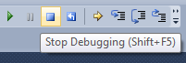

To remove a breakpoint, click again on the red dot. It can take some time to get used to using the debugger, but it will be time well-spent, as it can usually save you a lot of time down the road when your program doesn’t work correctly.

Drawing Graphics

Generally, you will use the PictureBox control to display graphics. It can display shapes we draw ourselves and also common image formats such as JPG, GIF, BMP, PNG, etc. We already showed how to display a static image (just add a picturebox to the form, click on the image property, Import a local resource, and pick the file that corresponds to the image you want displayed).

The graphics screen is set up as a grid of pixels where the upper left coordinate is 0,0. This is relative to where the PictureBox is on the form. The x coordinate then grows out to the right, and the y coordinate grows down toward the bottom. For example, in the picture below the white pixel is at coordinate (600,400).
Colors

There are lots of different pre-defined colors available from the Color object, e.g.:

Color.Black Color.DarkGray Color.Gray
Color.Blue Color.Green Color.LightGray
Color.Cyan Color.Magenta Color.Orange
Color.Pink Color.Red Color.White

To create our own color, we can specify the color we want in RGB (red, green, blue). To do this, use:
Color.FromArgb(Red, Green, Blue)

where Red, Green, and Blue are values in the range 0-255. 0 is the darkest intensity of each color and 255 is the brightest intensity of that color. The colors are mixed somewhat like the colors that make up light, e.g. red + green = yellow.

For example:

Color.FromArgb(0,255,200);

Creates a green-blue color, with stronger green than blue. There is no red since its value is 0.

Here is a visualization of the RGB Color space projected onto a cube:

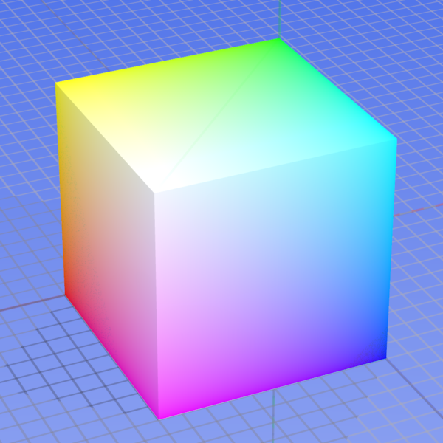

The red corner is where R=255, G=0, B=0. The Blue corner is where R = 0, G = 0, B = 255. The white corner is where R = 255, G = 255, B = 255. Black is hidden in the rear of the cube.

Image MouseClick Event

If you want to know where a user is clicking on an image, you can access the MouseClick event (not the Click event!). Let’s make an example using an image from Scholastic’s I Spy game. Below is a picturebox named pboxISpy that has the following image loaded into it:



Let’s make a simple game where the user has to click on the two butterflies hidden in the picture. We can do this by finding out the coordinates for rectangles that surround each butterfly. If the user clicks in those coordinates then we know that they’ve clicked on a butterfly.

To find the coordinates we could use a paint program, like Paint. As you move the mouse on the image, the coordinates are displayed in the status bar:

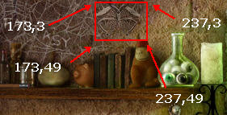

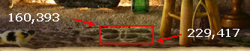

For the top butterfly, if the user clicks anywhere where the X coordinate is between 173 and 237 and the Y coordinate is between 3 and 49, then the user will have clicked on the top butterfly.

Similarly, if the user clicks anywhere where the X coordinate is between 160 and 229 and the Y coordinate is between 393 and 417, then the user will have clicked on the bottom butterfly.

Another way to find these coordinates, other than by using a paint program, is to output the coordinates from C#. Put the following in the MouseClick event for the picturebox:

private void pboxISpy_MouseClick(object sender, MouseEventArgs e)
{
Console.WriteLine(e.X + " " + e.Y);
}

Now, run the program. If you click in the picturebox, the Output window will show the coordinates that you are clicking on. You could then click on various points of interest on the image to find their coordinates.

Here is a program that goes into the MouseClick event that then pops up a messagebox if the user found one of the butterflies:

private void pboxISpy_MouseClick(object sender, MouseEventArgs e)
{
if ((e.X > 173) && (e.X < 237) &&
(e.Y > 3) && (e.Y < 49))
{
MessageBox.Show("You found the upper butterfly!");
}
else if ((e.X > 160) && (e.X < 229) &&
(e.Y > 393) && (e.Y < 417))
{
MessageBox.Show("You found the lower butterfly!");
}
}

As a class exercise we’ll use the debugger to fix errors in the I Spy program that is supposed to stop when both butterflies are found and not allow a butterfly to be clicked more than once.

