Wildwood: The Evolution of L-System Plants for Virtual Environments

Kenrick J. Mock
Intel Architecture Lab
Intel Corporation, 2111 NE 25th Ave, Hillsboro OR 97124
Kenrick_J_Mock@mail.intel.com

Abstract

This paper describes the Wildwood project. In this work, a genetic algorithm was applied to a simplified L-system representation in order to generate artificial-life style plants for virtual worlds. Acting as a virtual gardener, a human selects which plants to breed, producing a unique new generation of plants. An experiment involving a simulation-style fitness function was also performed, and the virtual plants adapted to maximize the fitness function.

1. Introduction

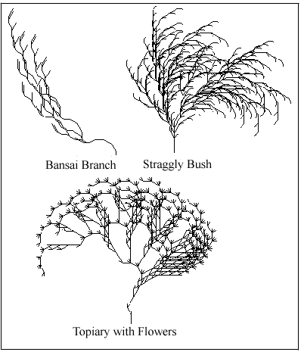
Due to the recent growth of the Internet, personal computers have been transformed into communications devices. This is exemplified by the growth of virtual chat spaces that began with text chat and have moved to 2d and 3d graphical environments that now incorporate a large degree of realism. Users worldwide populate these virtual worlds in the form of avatars. Most of these worlds are very antiseptic and contain only static manmade objects.
However, as users explore virtual worlds, they should be able to interact with native objects, not simply with other avatars. One can imagine a life-like and immersive virtual world populated with virtual plants, insects, birds, and other organisms that all “live” within their own computerized ecosystem. The goal of the Wildwood system is a first step towards this goal through the introduction of plants to virtual worlds. These virtual plants are derived from artificial life principles. The Wildwood system is named after the Wildwood Arboretum in Pennsylvania.
Wildwood’s plants are based on L-systems. Lindenmayer introduced the formalism known as L-systems in 1968 to simulate the development of multi-cellular organisms [1,2]. While biologists originally used L-systems to create biological models, scientists in computer graphics have garnered recent attention by rendering attractive and sophisticated graphics based upon L-systems formalisms [3]. Traditionally, scientists carefully create plant models via L-systems, parse the resulting representation, and then render a graphic representation to the screen.
In contrast, Wildwood uses the genetic paradigm to create plants. In place of a handcrafted L-system representation created by scientists, Wildwood generates a population of L-system representations at random. Next, the representations are rendered to the screen as plant individuals and a fitness function is applied to each individual. The fitness function may be a computational evaluation based on how well each plant will survive in the environment, or it may be a human that identifies the most interesting-looking plants (i.e., hand bred). The most fit plants “survive” and the plants for the next generation are constructed by combining the L-system representation of fit parent individuals from the current generation. The process continues until the user intervenes. A sample of plants that were evolved via human selection is shown in figure 1.
Figure 1. Hand-bred plants.
Bansai: A=F-FFA+[FAFA+FFF]F
Bush: A=FAF-+[-A+A[A]]FF[F+AFF+AFAf]
Topiary: A=FF[-FF+[F]+FAAA-A-A-A][F]
The technique of selection via human aesthetic preferences is similar to that employed by genetic art programs [4]. Another similar technique was employed by Dawkins’ Biomorph system [5]. Both system differ from Wildwood in the sense that the genetic algorithm manipulates different chromosome models. The art chromosome defines a set of parameters that make interesting pictures, the Biomorph chromosome defines parameters good for evolving biocritters, and the Wildwood parameters are attuned towards generating plantlike structures. From a computational perspective, Wildwood is also similar to Jacob's work on evolving flowers via L-Systems [6]. Jacob's Evolvica system generated plants using a high-level, context-sensitive L-system. Wildwood represents a simpler and more applied approach that facilitates evolving entire forests on individual PC's.

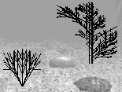
Figure 2. Intel MU SDK
Computer generated flower-like plant and bush-like plant

2. Intel MU SDK Virtual Environment

Wildwood is capable of operating within the Intel Multi User SDK virtual environment, which was formerly idMoo or Intel distributed MOO [7]. Wildwood is also capable of running as a standalone Java program. Since the goal of this paper is to describe Wildwood, only a brief description of the Intel MU SDK is presented here.
The Intel MU SDK supports a graphical, multi-user environment. In addition to supporting avatars and chat, the SDK also provides a framework for automatic object replication, secure messaging, negotiation, and object management. These functions operate upon all objects in the environment. In this manner, any object (rocks, trees, fish, bots, etc.) can exhibit arbitrarily complex encoded behavior.
Wildwood plants are an example of such an object. When a virtual plant is created within the MU SDK environment, an L-system representation is selected and the plant is graphically rendered to the screen. Any public interfaces that have been defined for the plant may then be invoked. For example, another plant may wish to cross-pollinate and could do so by sending a message to invoke the other plant’s pollination function. Similarly, a user may invoke parameters that control the plant’s growth, size, or other settings. Each plant runs its own code within its own thread. Consequently, any action the plant may take to change itself becomes effective within the environment without requiring explicit user control.
A cropped screenshot of one room within the MU SDK environment is shown in figure 2. The Wildwood system generated the flower-like plant and the bush-like plant.

3. L-system background

Wildwood currently implements a simple “turtle-graphics” version of L-systems that is based on a context free grammar [8]. The L-system grammar is used to generate strings that are then parsed to produce graphical output.
The string grammar in Wildwood consists of a single production rule. Each term in the production rule may be associated with an operation. In a more general system, there could be multiple rules and each term could correspond to a separate production rule, but this was not implemented in Wildwood.

3.1 L-System grammar representation

As an example, given the rule “A=fF”, the term “A” will be replaced by the terms “fF”. This represents a single execution of the transformation rule (Order=1). There is a more interesting result when recursive definitions exist. For example, given the rule “A=FfAFF”, then upon executing a single transformation rule, there will be no replacement of the A on the right side of the equation, and it will be ignored:
Original : A=FfAFF
Order(1) : FfFF
However, upon executing two transformation rules, (Order=2) a single replacement of A will occur:
Original : A=FfAFF
Order(2) : FfFfAFF
: FfFfFFFF
This process may be repeated up to an arbitrary order. For example, Order(3) for the same rule results in the string “FfFfFfFFFFFF”.

3.2 L-system terms

The terms that make up the L-system grammar are actual turtle-logo style commands that can be directly interpreted to draw the plant. The system begins with a “turtle” facing upwards that has a pen attached to his belly. As each term in the string is read, a corresponding command is executed that moves the turtle in some way. The result is left visible by the pen’s trail. Wildwood currently parses only the following limited set of command terms:

F : Move forward and draw a line segment
f : Move forward without drawing a segment
- : Rotate left R degrees
+ : Rotate right R degrees
[ : Push current angle/position on stack
] : Pop and return to state of last push
In Wildwood, the rotation angle R was preset to 30 degrees. The push and pop operations comprise a bracketed L-system and is necessary to model branching behavior.

As an example of how the rules produce a picture, consider the grammar:
A=F[-F][F][+F]A
At Order = 3, this grammar is expanded to the string:
F[-F][F][+F]F[-F][F][+F]F[-F][F][+F]
The first “F” will cause the turtle to move up one segment, drawing a line. The next “[“ will save this state on the stack. The “-“ turns the turtle 30 degrees left. The next “F” moves the turtle forward, drawing a segment. The next “]” returns the turtle to the original state, facing directly upwards after one segment was drawn. The process is repeated moving directly ahead, and then towards the right 30 degrees. When repeated, the end result is a wheat-like plant that grows straight up with appendages out towards the side. This plant with Order=4 is depicted in figure 3.
Figure 3. Wheat-like Plant

Using only these simple commands and replacement within a single rule, a large number of plantlike objects can be created. With a larger command set and multiple propositions, additional classes of plants and other organisms may be modeled.

4. Genetic Algorithm Component

The genetic component of Wildwood operates upon the principles of standard genetic algorithms [9]. The genotype or chromosome is the compact string representation of the L-system, e.g. “A=F[-F][F][+F]A” using the example from section 3.2. The phenotype is the rendered version of the plant. A population of plant individuals are initially created at random, the fitness function is applied, genetic operations are applied to create a new generation, and then process repeats until stopped by the user.

4.1 Genetic Operations

In general, the crossover and mutation operations are performed the same way as in traditional genetic algorithms. For crossover, two individuals are selected with probability proportionate to their fitness, and children are produced by randomly selecting substrings from each parent. The substrings are then swapped in their respective locations to produce the children. This is illustrated below:

Parent1: A=F[-fF++F]fAfFA
Parent2: A=FFAFFFAFFF

Child1: A=F[-fFAFFF]fAfFA
Child2: A=FFAFFF++F

However, care must be taken so that a child does not become inconsistent with respect to the stack operations. This may occur if substrings are selected that result in imbalanced brackets:

Parent1: A=F[-fF++F]fAfFA
Parent2: A=FFAFFFAFFF

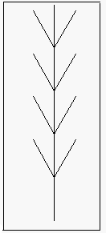
Child1: A=F[-fFFFfFA
Child2: A=FFAF++F]fAAFFF

Child1 now has a push operation with no pop, while child2 has a pop operation with no prior push. To address this problem, substrings are only selected if they contain either no brackets or a balanced number of brackets. This is similar to the technique used in genetic programming, where entire subtree S-expressions are selected for crossover [10].
To compute valid substrings, Wildwood first selects a random start position and then scans toward the end of the string while counting the number of brackets encountered. Valid positions where the quantity (Sum(“[“)-Sum(“]”)) equals 0 are stored. If a “]” is encountered before a “[“ then all other future positions are invalid. One of these locations is then selected at random as the ending position of the substring. The process is repeated in the event that no ending positions are valid.
The mutation operator was implemented by selecting a valid substring and then replacing the substring with a randomly generated string.

4.2 Random String Generation

To generate random strings for either mutation or initializing the population, a random rule length is first computed. For simplicity, a length between 4 and 20 was selected. Then, terms from the set {“f”,”F”,”[“,”]”,”+”, ”-“, “A”} were selected at random to fill the string.
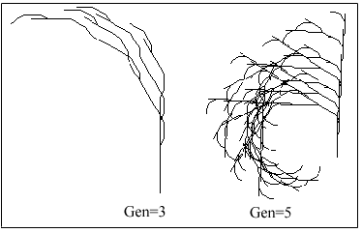
To ensure balanced brackets, the probability of a “]” increases proportionally with respect to the remaining slots in the string and the number of right brackets necessary to balance the production rule. For example, if there are two remaining terms to generate and one unbalanced “[“, then the probability that the next term will be a “]” is 0.5. If there is only one remaining term to generate and one unbalanced “[“, then the probability that the last term will be “]” is 1.
While a maximum length was imposed for random string generation, note that the length of individual strings may grow arbitrarily long through successive crossover operations.

5. Execution – Hand Bred Plants

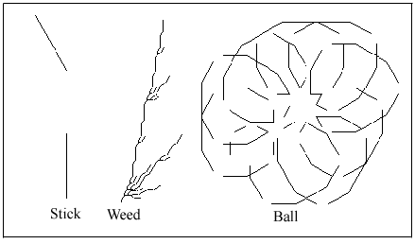
Wildwood was primarily executed in hand-bred mode. In other words, humans acted as virtual gardeners and selected the most interesting looking plant for each generation. The population was initialized with 5 to 10 plants. At each generation, the human assigned fitness values and selected one plant to keep. The mutation rate was 5% and the order of all plants set to 4.
Figure 4. Plants from Generation 0
Stick: A=Ff-F
Weed: A=F+F[+-A]Ff-AFFAF
Ball: A=F+f+AAFF+FA

Figure 4 shows a handful of plants from generation 0. Since L-systems are random and capable of modeling fractals and objects other than plants, initially many individuals do not look like plants at all. For example, the plants labeled “Stick” and “Ball” do not look like plants. Nevertheless, it is possible to randomly generate interesting looking structures, some of which may be very plant-like. The plant labeled “Weed” evidences this.
Figure 5 shows the user’s favorite plants during generation 3 and 5 of the evolution process. Although the plants are derived from the “Weed” plant of generation 0, there is little resemblance to the original plant at this stage. However, there is a definite resemblance between the plant in generation 5 and the plant in generation 3, as both share similar production rules.
The user stopped the process at generation 7 after evolving a diamond-leaf plant. An examination of the production rule reveals similarities between ancestors, but the genetic operations have inserted new material in the middle of the genotype.
Figure 5. Favorite plants during evolution
Gen 3 : A=FF[F[A+F[-FF-AFF]]]F
Gen 5 : A=FF[F[A+F[-FF-+F[-FF-FFA[-F[]A[]]]AFF]]]F

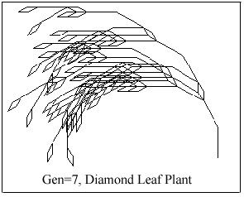
Figure 6. Final favorite plant
A= FF[F-[F[A+F[-[A][]]]][A+F[-F-A[]]]]F

6. Execution – Environment Simulation

Although Wildwood primarily ran under user control, an initial experiment was performed to see if L-system plants would evolve as expected if a simulated environment produced the fitness function. For example, a plant’s survival may depend upon its height, root depth, leaf size, attractive flowers, ability to withstand wind, proximity to water, etc. Ideally, all of these factors would be modeled and contribute to determine a plant’s fitness. Unfortunately, this type of massive undertaking was beyond the scope of the project. Instead, a feasibility study was conducted via a simple fitness function. The fitness function rewarded plants that were short, but wide:

F(plant)=Width(plant)+(S/Height(plant))

S was a constant set to 30 and the system attempted to maximize fitness. The large value of S rewards plants more for being short than for being wide. A smaller value has the opposite effect. Although contrived, this fitness function could be appropriate for an environment that favors a ground-cover type of plant. For example, an arid, windy region may be inhospitable to large skinny trees but favorable to short bushes.

The population was initialized with 20 individuals, the mutation rate set to 5%, and order set to 4. A selection of
the most fit individuals from generation 0-12 are shown in figure 7.
Figure 7. Best individuals, Gen 0-12
Gen 0 : A=F+[+fAA[fA]fFF[A]]F
Gen 4 : A=FF[-FFAFAAF][]A
Gen 12 : A=F-f[-FFF]AF

Initially, the best individuals are plants that are wide, but no short plants were generated. The plant in generation 4 is even wider, and only slightly shorter. However, by generation 12, a plant has evolved with a larger fitness that is short and somewhat wide. At this point the population had converged, although a longer run could still have produced fitter individuals.
This small experiment suggests that the L-system plants are capable of adapting to environmental conditions depending on what type of model is constructed for the fitness function.

7. Conclusions and Future Work

Wildwood represents exploratory technology created with the intent to enrich virtual worlds. Its current incarnation is akin to genetic evolutionary art. The genetic operations allow a virtual gardener to explore new variations of plants. The system also allows novices to play with and evolve plants that suit their preferences without the need to learn about L-systems or production rules.
Many enhancements are possible that can generate more interesting and varied plants. Foremost is the addition of new terms to control segment width and color. Moreover, the incorporation of multiple production rules would also support the generation of new classes of plants. Individual rules may be trained independently to form a hierarchical system. For example, one set of rules may form leaves while another may form flowers or roots.
Another enhancement is the addition of parameters to the genetic operators. Currently, the GA only operates on production rule strings. Variable rotation angles, starting angles, and order could produce other interesting virtual plants at different stages of development if they were parameters that the GA could adjust.
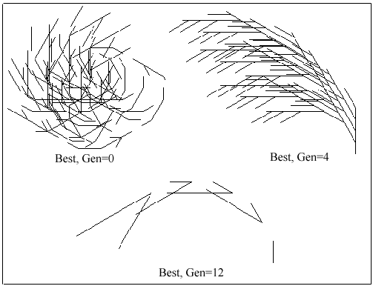
As a simulation tool, a great deal of work needs to be done modeling the environment and the effect that the environment has on plants in order to produce useful results. In the near term, this is most easily accomplished by focusing on specific environmental factors, such as wind, rain, or sunlight.
Overall, many exciting opportunities remain to be explored from both an aesthetic and scientific perspective. Wildwood is a first step towards uncovering new possibilities and examining the resulting issues.

8. Acknowledgements

The Java L-system renderer is based upon a free applet written by Mark Masse. Scott Lewis integrated the Wildwood system with the Intel MU SDK.

9. References

[1] A. Lindenmayer. Mathematical models for cellular interaction in development, Parts I and II. Journal of Theoretical Biology, 18, 1968, 280-315.
[2] P. Prusinkiewicz. Graphical applications of L-systems. Proceedings of Graphics Interface 86 – Vision Interface ’86, 1986, 247-253.
[3] Prusinkiewicz, P. and Lindenmayer, A. The Algorithmic Beauty of Plants. Springer-Verlag, Berlin, 1990.
[4] K. Sims. Artificial evolution for computer graphics. Computer Graphics, 25:4, 1991.
[5] Dawkins, R. The Blind Watchmaker, Norton, New York, 1986.
[6] C. Jacob. Genetic L-System Programming: Breeding and Evolving Artificial Flowers with Mathematica. IMS´95, Proc. First International Mathematica Symposium, Southampton, Great Britain, UK: Computational Mechanics Publications, 1995, 215-222.
[7] The Intel Multi-User SDK. Sept. 1997,
http://labtoys.hbtn.portland.or.us/Idm20Worlds/docs/public.
[8] A. Szilard. and R. Quinton. An interpretation for DOL systems by computer graphics. The Science Terrapin, 4, 1979, 8-13.
[9] J.Holland. Adaptation in Natural and Artificial Systems. Ann Arbor, MI: University of Michigan Press, 1975.
[10] J.Koza. Genetic Evolution and Co-Evolution of Computer Programs. Proceedings of the Workshop on Artificial Life II, Santa Fe, New Mexico, 1990, 603-629.

